* **Activity 2:**

Inserting Rows with Null Values

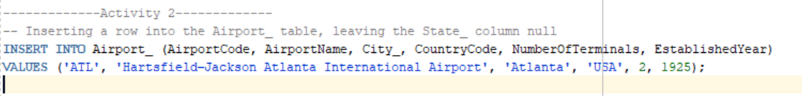Implicit method (Omit the column):

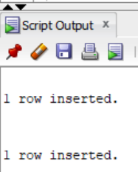OUTPUT:

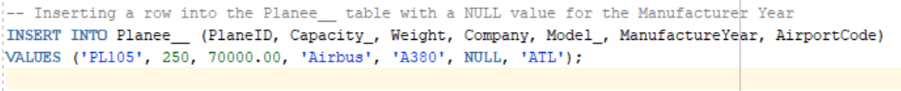Explicit method (Using NULL keyword):

OUTPUT:

